TN-028
SPB Preamplifier Enclosure
Dielectric Withstanding Voltage (Hypot) Test

Greg Dalton
7/16/09

- Purpose
This Technical Note summarizes the end to end test performed on the RBSP SPB ETU for dielectric withstanding voltage. This test qualifies the design and interconnectivity of the SPB harnessing, connectors, slipring, composite cable, and preamplifier enclosure.

- References
Test conducted per MIL-STD-202G Method 301 / MIL-STD-1344A Method 3001.1 (connectors).

- Test Apparatus
Associated Research 3670 Hypot III tester Serial Number 9331523, calibrated 3/28/2008.

- Test Article
One RBSP Spin Plane Boom ETU, partially deployed (1m), preamplifier enclosure disassembled and preamplifier removed.

- Settings
Test M2: 2 sec ramp-up (DC test), 60 sec dwell, 2μA overcurrent trip (to capture arcing), Arc detect set to 9 (max sensitivity), followed by a 2s 900V >10Gohm IR test. Test at ambient temperature and pressure on an ESD safe workbench.

- Procedure
  - Place one Hypot tester lead clip on the SPB preamplifier enclosure cable strain relief spring, and the other lead on the guard surface of the preamplifier enclosure, as seen in Figure 1.
  - Perform hipot and insulation resistance test per specifications in Section 5 above.
  - Remove test leads from preamplifier enclosure. Place the ground lead on the SPB chassis and the positive lead on Pin-8 (usher). Run test.
  - Place positive lead on Pin-4 (Guard) and run test.
  - Place positive lead on Pin-1 (Vsphere) and run test.
  - Place negative lead on Pin-8 (usher), positive lead on Pin-4 (Guard), and run test

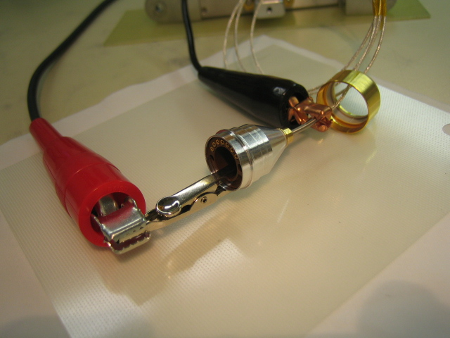
Figure 1. Preamplifier enclosure test

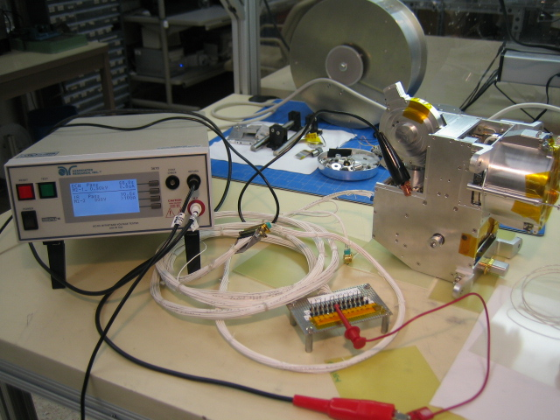
Figure 2. Harness and internal wiring test

- Results
All test were satisfactory: DC withstanding voltage of 900V for 60 seconds and insulation resistance >10Gohm.

